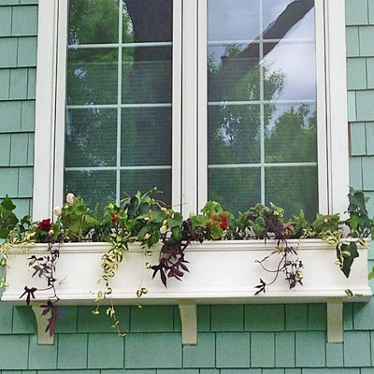

*PHOTOS OF WINDOW BOXES FOR WINDOW GARDENS*