Rural Roads

From the Native American times of aboriginal tribes, transportation throughout Western New York and the Finger Lakes was of simple means – by foot, raft, or canoe. In the relatively short time that the white man has lived here, the various means of transportation have changed immensely. They have progressed from the settlers’ migration on foot or horseback, by wagon, carriage, or stagecoach, by raft, rowboat, or steamboat, with horses, mules, or oxen, throughout the eighteenth and nineteenth centuries to the automobiles, trains and trolleys of the twentieth century. With the progressive growth in population, homes and farms, the miles of footpaths evolved into dirt or gravel roadways, and then to an exponential growth in paved highways, requiring an equally intensive growth in the manpower, materials, and cost necessary to construct and maintain them.
In the 19th and early 20th centuries, the extensive highway departments of today did not exist, nor did the sophisticated equipment used in keeping our “highways” in good useable condition.
In 1794 the road from old Fort Schuyler on the Mohawk River through Canandaigua to the settlement of Canawaugus on the Genesee River, today’s Routes 5 & 20, was officially known as the Great Genesee Road. On April 1, 1800, the Seneca Road Company was chartered for the purpose of completing the road and the portion of the Genesee Road from Utica to Canandaigua was improved and operated as a toll road known as the Seneca Turnpike.
Another old Indian trail, a footpath turned stagecoach road, turned plank road, is today’s Route 21. The trail began in the vicinity of Geneva and went west to Canandaigua on a path now occupied by US 20 and NY 5. It continued north from Canandaigua, passing through the villages of Palmyra and Marion before reaching the Lake Ontario shoreline at Pultneyville. Construction to convert the Canandaigua–Marion section of the trail into a road was also completed in 1794. The Canandaigua–Pultneyville highway served as a post road (designated for the transportation of postal maill) in the years that followed . Initially a corduroy road (or log road), in 1849 it was rebuilt as a plank road and tolled. The highway fell into disrepair over the years, leading travelers to conceive ways to avoid paying toll. The toll booths were eventually removed, and the road was later covered with dirt and converted into a stage road. By the 1920s, the state of New York had assumed ownership of the Canandaigua–Pultneyville highway. (Wikipedia) There was a toll house here in the Town of Canandaigua, situated a little east of the HANNA farm (2540 Route 21N). The author believes this to be the last one to be used.
Plank roads were still popular into the 20th century where the first motorists, struggling to negotiate muddy roads and bumpy gravel roads with their Model Ts, were all too happy to have at least a somewhat level surface on which to drive.
Like many inventions, the plank road was a progressive idea and improved local travel tremendously. However, after a few years of wear, the planks began to warp and rot away. The cost of repair, more lumber, gravel, toll buildings, employees, and management all came into play. As the planks deteriorated, gravel was used to compensate, making for a slower and bumpier ride.
In the early 1800’s the “Laws of the State of New York“(New York State Library, Digital Collection), enacted by the Legislature, allowed for the election or appointment of “Overseers of Highways”. As early as 1846, the Canandaigua Town Board, agreed that they needed, not only three highway Commissioners, but also 64 Overseers of Highways. At this point in time, the Village of Canandaigua was a part of the Town of Canandaigua.
The system of overseers was an old system which provided for appointed residents to inspect sections of the Town’s highway, called “beats” or districts each with an individual “pathmaster” or district superintendent, or “overseer”. It was the responsibility of the overseer to provide the Town Clerk with a list of names of all inhabitants in his road “district”, who were liable to work on the highways. Every person who owned or occupied land in the town was required to be “assessed” for highway labor, either in actual labor or monetarily.
At the annual meeting of the Town on April 7th 1846, the Board, consisting of William Gorham, Supervisor; G. W. Bemis, Town Clerk; and Zebina Lucas, Jabez Metcalf, Solomon White, and Lyman Cooley, Justices “voted that there be elected, for the ensuing year, three Commissioners of Highways, two Overseers of the Poor, and three Assessors. ”In addition, the following 64 individuals were appointed Overseers of Highways”:
Isaac Parrish Hiram Hubbard Cyrus Woodruff Cornelius Davis Oliver Gunnison Calvin Straight Andrew Sleight William Case Joel Howey Roswell Remington Josiah Sutherland James Gillet Francis Castle John McConnell John Brockelbank Albert Cooley William Sutherland Edmund Tiffany Ansel Debow Stephen Sanford Joseph Cove l John Trambley J. M. Miller Holmes Lucas James Blair Zophan Hickox William Prouty Ezra Forbes Samuel Hudson Calvin Crane Robert Jackson Sam’l Gardner Levi Beebe Luther Brown Avery Pratt L. B. Gunnison John Beeden Wells Gooding Alex Murray N. J. Smith Lyman Bonney John Trickey Arnold Lake Eli Ingraham Herman Barnes Hezikiah Jarvis E. W. Crane James Doolittle Seth Beeman Elijah Harrington Wm. W. Gorham Sam’l Brockelbank William Warfield ? Curtis Oren Crittenden Henry Howard T. L. L. Menteth Moses Perkins O. Smith Hezekiah Townsend Elizah Montanye Moses Ward Orin Wilcox William Marvin

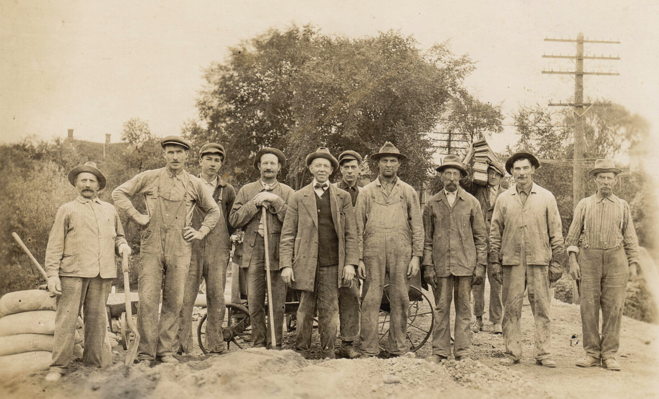

Highway Work Crew – Made Up Of Town Residents – Dated ca 1907 Photo Courtesy of Preston Pierce

Whether plank or gravel or macadamized, the Town’s roads needed maintenance for several reasons. The farmers needed to be able to get to the village for necessary supplies, and the villagers needed to have the farmers bring their products (milk, fruit, vegetables and meat for consumption) to them, and for the all important interaction between family and neighbors.
“The fact is that nearly all town highways in upstate New York are “highways by use.” These are rights-of-way for travel by the public. (An interesting sidebar to the fact that town highways are highways by use is that property owners need permission from intervening property owners to bring in electric or telephone utilities. Town boards have no power to grant this permission.)
In New York, town roads cease to be “highways” only if they are formally abandoned according to a legal procedure established in the state law (there is also a procedure for qualified abandonment), or if they are neither maintained by the Town nor traveled by the public, including by foot, for at least six years.
Contributing to inaccuracies about town highways is the fact that in 1908 the ancient system of many town highway “beats,” or districts, each with an individual “pathmaster,” or district superintendent, was discontinued. Highway records, which were entered annually, ended at this time in most towns, but the fine old records are often carefully sequestered in the town clerk’s safe.”
By: Carol W. LaGrasse (Parts of an article entitled “Still a Town Highway – Worth Commenting” from the New York Property Rights Clearinghouse, Summer 2003)
The point of all this is that today’s residents don’t necessarily appreciate the evolution of Town Highway construction and maintenance from the early days of highway maintenance to today’s technology. The idea of residents actually having to grab their shovels and join their neighbors in shoveling or scrapping the road, or cleaning out the ditches and culverts is probably unbelievable to today’s homeowner.
This period of time, near the end of the 19th century and the beginning of the 20th, brought to light a new era of Town Highway construction and maintenance. And the man who made some of the most remarkable changes became known, not only locally, but throughout New York State and many of the eastern states as the “Father of Good Roads”, Canandaiguan Ira P. Cribb.
The following are snippets from Ira’s obituary, as it appeared in the Canandaigua Daily Messenger, on June 10, 1943
Death Claims Ira P. Cribb, 92 – Called “Father of Good Roads”
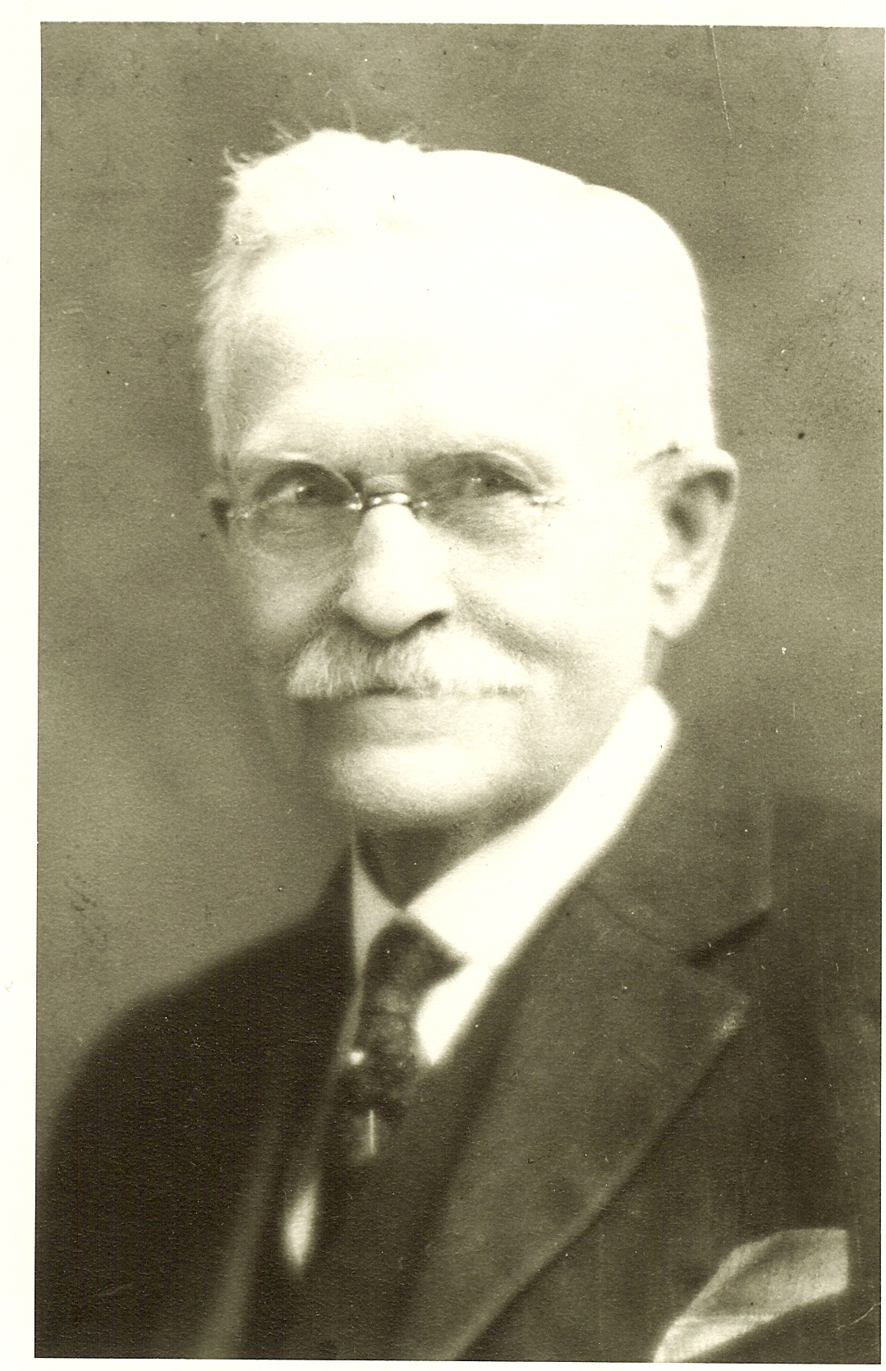
Ira P. Cribb, 92, known as the “Father of Good Roads,” in Ontario County and throughout the state, died in F. F. Thompson Hospital this morning at 2:10 after a three weeks’ illness.
Former chairman of the Board of Supervisors, town highway commissioner and state supervisor of highways, Mr. Cribb was one of Canandaigua’s oldest and most respected citizens. He was the father of Supreme Court Justice Fred D. Cribb, of this city.
Born in the Town of South Bristol, Feb. 21, 1851, Mr. Cribb was the son of Mr. and Mrs. Joseph P. Cribb who in early life had moved to the farm home on the Cribb-Butler Road in the Town of Canandaigua, where he resided until moving in 1906 to the home which he had since occupied in this city. He was educated in the old Naples Academy.
Always active in the Republican Party, Mr. Cribb began his political career in the Town of Canandaigua when he was elected in 1889 as town commissioner of highways. It was while serving in this capacity that he became intensely interested in the improvement of roads and was instrumental in effecting the purchase of the first stone crusher publicly owned in this county.
All roads in that day were of a dirt or sand surface, subject to mud and ruts during winter and summer. Mr. Cribb directed the building of the first crushed stone road in the State of New York through the appropriation of public monies. A sample 40 rod strip was constructed on the Centerfield Road, now an arterial highway to Buffalo and later a mile strip was built on the West Lake Road near what is now the Yacht Club. Other roads soon followed and in a short time delegations came from as far as North Carolina to see these new stone roads.
Following completion of the mile strip on what is now Routes 5 & 20, Mr. Cribb traveled throughout the state in the interest of the crushed-stone road and eventually was sent by Gov. Odell to a National Good Roads convention in Detroit as a speaker from this state.
In 1898, Mr. Cribb was elected Town of Canandaigua Supervisor, and thus, to the Board of Supervisors. Twice re-elected, he served for two years as chairman of the Board of Supervisors. During the first year he was sent to Albany to attend the first convention of the New York Good Roads Association and was there appointed a member of the legislative committee and elected a member of the state committee on which he served for eight years, including several terms as secretary. These forces carried on a fight in the legislature for highway appropriations and legislation favorable to highway improvement.
Mr. Cribb resigned as supervisor in 1906 to accept the position of state supervisor of highways in the Town Highway Bureau, the first highway department established by the state in 1905. He served in this capacity until he retired on Jan. 1, 1924, when the Bureau was abolished by consolidation of the Highway Department under the New York State Department of Public Works.”
Ira’s son, Fred Cribb, as a fledgling Village of Canandaigua attorney, wrote the charter required when the Village of Canandaigua became a City in 1913, thus separating the City and Town, and he would later become a Surrogate Court Judge, as his son, Joe Cribb.
Ira Cribb’s macadamized (oil and stone) roads became the standard for most of Western New York, because they were economical to build, their condition was just as good in December or March as they were in July or September. They increased the value of the adjoining farms many times the cost of the roads, and the subsequent cost of keeping them in good repair became much less than the cost of “keeping poor roads in poor repair”.
That first publically owned stone crusher in the County, which cost the taxpayers $1500.00, in conjunction with the “Pitts” (of Buffalo) steam roller purchased in 1895 for $3450, and the steam roller (shown below) prior to 1918, ushered in the new era of utilizing public equipment, materials, and personnel, in addition to other citizen labor, paid for through taxation, to vastly improve the condition of the Town’s highways.
In an article titled “A Source of Wealth” published by the Rome Semi- Weekly Citizen on Tuesday, April 6, 1897, stoned rural roads were referred to as Canandaigua Roads – “Senator Stone says Good Roads would prove such to farmers”. The article goes on to say “It was the farmers who built the Canandaigua roads at their own costs, by direct taxation, and who petitioned the Legislature for the right to increase the legal limit of their taxation”. It is painfully obvious that “good roads” were important to the farming community.
And in the Rochester D & C on September 25, 1904 appeared the following article:
Headlined: “Improved roads at $1500 per mile- Cost is even less in Canandaigua” (Remarks by Monroe County Attorney, Arthur Warren to a D& C reporter).
“I have just returned from Canandaigua where I spent the day in inspecting the improved highways of Ontario County, and particularly those in the Town of Canandaigua, in company with Frank Z. Wilcox of Syracuse, Vice President of the National Good Roads Association; Supervisor Ira Cribb and Fred G. Douglass, Commissioner of Highways in the Town of Canandaigua and one of the street commissioners of the Village of Canandaigua.
Four miles of what is known as “Middle Road” (I believe now Route 21 South, NOT Middle Cheshire Rd.) was built in 1892 at a cost of $1000 per mile, the stones being furnished free, has never been resurfaced or had any material put on for repairs and are in splendid condition at this time.
The same for four miles of North Bloomfield Road built in 1896.
Of course these roads have been scraped and rolled with a steam roller each year and have received intelligent and systematic care”.
Ira was replaced as Town Highway Superintendent by Fred G. Douglass, who besides being Ira’s brother-in-law, was first elected to the Superintendent’s post in 1895 and was re-elected to that office until 1906. He continued Ira’s work as a proponent of good highways, and became the first Ontario County Highway Superintendent and was a state highway inspector when he was fatally injured in an accident in 1918.
Fred Douglass was replaced by James P. McJannett who served until 1912. Successive Town Highway Superintendents and a few of the interesting stories of their terms follow:
George L. Atwater – 1912 – 1920; This decade was a busy one for the highway department. In 1914, $4000 was spent for bridge and highway work, which included individual and team (of horses) labor for snow removal, opening road, hauling gravel and lumber, clearing sluices, digging trench, and building forms (for bridge work). Town help wages were 25 cents per day per man, and 50 cents per day per team.
On September 27, 1916, a special Town Board meeting was held to investigate and take action regarding the traction engine (steam tractor) of Frank Hall going through the bridge on Bunnell Road . It was determined that the bridge was defective; wooden stringers had rotted.
In September 1919 a Special Improvement project was approved for West Lake Road from the Sulphur Springs (at Tichenor Point) south for as far as an expenditure of $5882.35 would take them, or 1.5 miles. The specs called for “local stone macadam with sub-base where needed – 8 feet wide by 6 feet deep, rolled in place, shoulders to have overlap 2 feet wide with screenings of clean gravel. Ditch lines standard at 24 feet.”
Cyrus Trickey – elected and served 2 months until he passed away in February 1920; Peter Haak was appointed and served until he lost the election in 1925 to Merton E. Montanye (1926 to 1930);
James K. Haire served from (1930 – 1943); Benjamin E. Emerson (1943 -1970); Harold Northrop (1970 – 1973); James Bell (1973 - 1994); James Hecker (1994 – 2010); and James Fletcher (2010 – present).
In a 2003 interview with Harold Northrop, he talked about some of his early memories. James Haire hired 10 men to put up 30 miles of snow fence each year. At that time the Town plowed State Route 21 South, plus 80 miles of Town roads, He improved the highway machinery by purchasing a 1936 big gravel truck, a 1936 Walters which was used until 1955. In 1938, he bought a Bay City shovel used until 1970. In 1946 Ben Emerson, the next superintendent, bought a bigger Walters. In 1965 the Town bought its first 10 wheeler. Sometime during this era the Town had two trailer dump trucks and another 10 wheeler.
And so it goes. The methods, means and materials of highway maintenance continue to improve, to the extent we, as residents, take an awful lot for granted.

